R. Vishnu Vardhan - 2520090166

WSL INSTALLATION
WSL Installation on Windows:
I am working on Windows, so I installed the Windows Subsystem for Linux (WSL) to get a proper Linux command-line environment instead of relying on Command Prompt or PowerShell. WSL lets Windows run a real Linux kernel and distribution (in my case, a Linux distro under WSL2) side by side with Windows, without needing a separate virtual machine or dual boot. After installing it with 'wsl --install' and setting up a Linux distribution, I get a full bash shell where standard Unix/Linux commands such as uname, ls, cd, mkdir, ps, top, df, and gcc/clang all work exactly as they would on a native Linux machine.
Below is the practical evidence of the OS-related commands executed inside my WSL terminal (running as root@Vishnu).

Practical Evidence
Screenshot 1: Checking the operating system using uname
1. uname

Screenshot 2: Displaying detailed system information
2. uname -a
This shows the kernel name, hostname, kernel release/version, and machine hardware — here it confirms the Linux kernel version running under WSL2 (microsoft-standard-WSL2), along with the build date and x86_64 architecture.
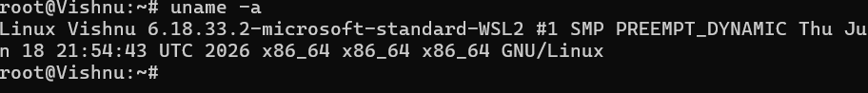
Screenshot 3: Checking process information
3. ps
The ps command lists the currently running processes for the shell session, showing PID, TTY, CPU time, and the command name.
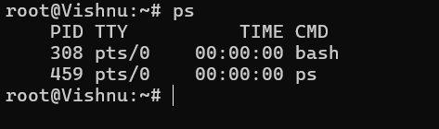
Screenshot 4: Checking system resource usage
4. top
top gives a live view of system resource usage — CPU load, memory and swap usage, and a ranked list of running processes with their PID, owning user, and resource consumption.
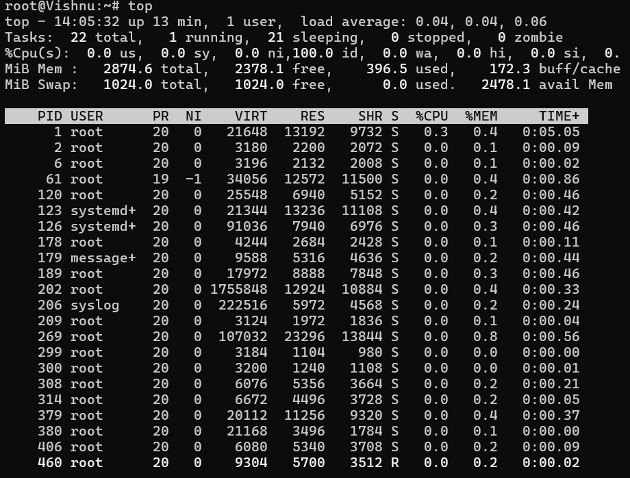

Conclusion
WSL successfully provides a native Linux command-line environment on top of Windows. All the required OS-level practical commands (uname, uname -a, ps, top, and similarly ls, cd, mkdir, df, gcc/clang) run directly inside the WSL terminal exactly as they would on a standalone Linux system. The screenshots above, captured from my own WSL session (root@Vishnu), serve as evidence of the practical work performed.

